COMPARISON EXERCISE: MongoDB vs Neo4j

Social Network Analysis

1. Objective
The objective of this exercise is to implement the same social network functionality using two different database technologies: MongoDB and Neo4j.
The exercise aims to understand the difference between a document-oriented database and a graph database while analyzing how each database handles connected data.
The objectives are:
- To create and store user information in MongoDB and Neo4j.
- To model relationships between users.
- To perform relationship-based queries.
- To analyze the differences between document and graph-based approaches.
- To understand the advantages of Neo4j for highly connected data.
- To compare query complexity and relationship traversal methods.

2. Procedure

Part 1: MongoDB Implementation

Step 1: Database Setup
A MongoDB database was created for storing social network information.
The database contains a users collection where user details are stored as documents.
Each user document contains:
- User ID
- Name
- City
- Interests
- Follow relationships

Step 2: Creating User Documents
User information was inserted into the MongoDB collection.
Two user documents were created:

Alice
Attributes:
- User ID: U1
- Name: Alice
- City: NYC
- Interests: Technology and Music

Bob
Attributes:
- User ID: U2
- Name: Bob
- City: LA
- Interests: Sports and Movies
The follow relationship was stored using an array containing user IDs.

Step 3: Querying Relationships in MongoDB
MongoDB aggregation operations were used to find second-level connections.
The aggregation pipeline used:
- Match operation to identify the required user.
- Unwind operation to separate relationship arrays.
- Lookup operation to join related documents.
- Project operation to display required information.
The query identified followers of followers for Alice.

Part 2: Neo4j Implementation

Step 1: Graph Database Setup
Neo4j was used to create a graph representation of the social network.
The graph consists of:
- User nodes.
- FOLLOWS relationships.

Step 2: Creating User Nodes
Users were represented as nodes with properties:
- User ID
- Name
- City
- Interests
Two user nodes were created:
- Alice
- Bob

Step 3: Creating Relationships
A relationship was created between users using the FOLLOWS relationship type.
Example:
Alice follows Bob.
The relationship is stored directly as an edge between nodes.

Step 4: Graph Traversal
Cypher queries were used to analyze relationships.
The following analysis was performed:
- Finding Alice's followers.
- Finding followers of followers.
- Traversing connected users.
Neo4j performs relationship traversal directly through graph patterns.

3. Comparison Analysis
Feature | MongoDB | Neo4j
Database Type | Document Database | Graph Database
Data Storage | Documents | Nodes and Relationships
Relationship Storage | Embedded arrays | Direct relationships
Query Language | MongoDB Query Language | Cypher
Relationship Traversal | Aggregation and lookup | Graph traversal
Complex Relationships | More difficult | Simple and efficient
Recommendation Systems | Requires complex queries | Naturally supported
Shortest Path Analysis | Requires additional logic | Built-in graph capability
Schema Flexibility | Very high | Flexible graph structure

4. Results and Analysis
The comparison showed that both databases can store and query social network information, but they use different approaches.
MongoDB provides:
- Flexible document storage.
- Easy handling of user attributes.
- Good performance for simple data structures.
However, relationship analysis requires multiple aggregation stages and joins.
Neo4j provides:
- Natural representation of relationships.
- Faster traversal between connected users.
- Simple queries for relationship-based analysis.
- Better support for recommendation systems and network analysis.

5. Screenshots
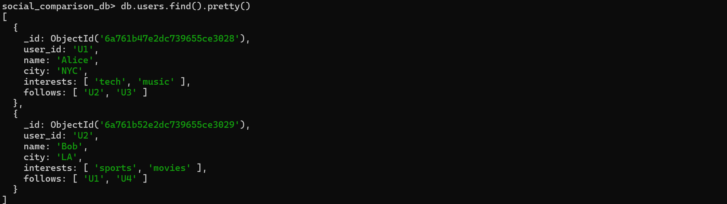

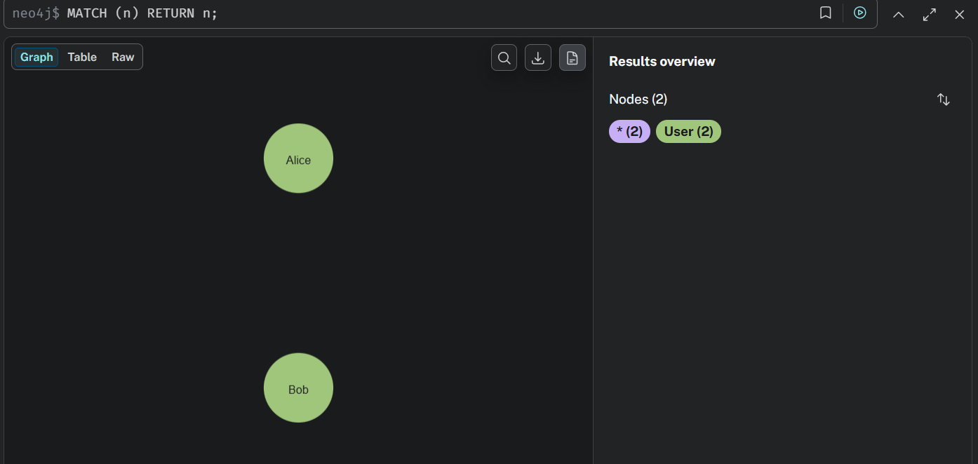

6. Conclusion
This exercise demonstrated the difference between MongoDB and Neo4j for implementing social network applications.
MongoDB is suitable for applications requiring flexible document storage and simple data relationships.
Neo4j is more suitable for highly connected applications because relationships are stored directly and can be traversed efficiently.
For applications such as social networks, recommendation systems, fraud detection, and network analysis, Neo4j provides a more natural and efficient approach compared to MongoDB.

